# Part D: A Possibly Explosive Social Media Post

Today, many of the biggest debates over the most important topics happen between people on social media, and they are often referenced as “news” by the readers that consume or participate in them. But, are those debates thoughtful and well-articulated or are they arguments driven purely by emotion such as fear, anger, frustration or are they filled with misinformation because some wish only to “get a reaction” because of pride, ego or some sense of self-importance? Wouldn’t it be better if these debates contained claims that were backed up with factual evidence and cited authoritative scientific reasoning? Today, you have discovered one such debate and will craft a response.

Translation:

TEPIC EXPANDS OVER GIGANTIC VOLCANO;

AN ERUPTION WOULD BE CATASTROPHIC

The most impressive volcano in Nayarit is the Tepic Volcano, which is cataloged as a supervolcano within its crater - the caldera could almost accommodate Sangangüey with everything and “the kitchen sink,” or more than half of Tepic.

The city continues to grow within its crater without any restrictions.

|  |
| --- |
| C:\Users\jch\AppData\Local\Microsoft\Windows\INetCache\Content.Word\Tepic3.jpegC:\Users\jch\AppData\Local\Microsoft\Windows\INetCache\Content.Word\Tepic3.jpeg |



**THE MOST DANGEROUS VOLCANO IN MEXICO, IN NAYARIT? ITS NOT EL POPOCATEPETL, NOR IS IT EL DE COLIMA, ITS EL CEBORUCO…**

About 1000 years ago El Ceboruco registered the biggest volcanic eruption in Mexico (we can see the remains of it as we travel along the Guadalajara-Tepic Highway.) After the colossal eruption, the volcano has erupted every 125 years, on average.

Apparently sleeping, but the giant is still active, with its last eruption occurring in 1870, it has been about 148 years, and it is not up for debate to rule out new eruptions, in fact, the so-called “Coloso Negro” (“Black Giant”**)** registered seismic activity and it is monitored 24 hours by the center of seismology and volcanology of the University of Guadalajara; but in Nayarit, no one is monitoring or making elaborate contingency plans! #ShareWithNayaritas

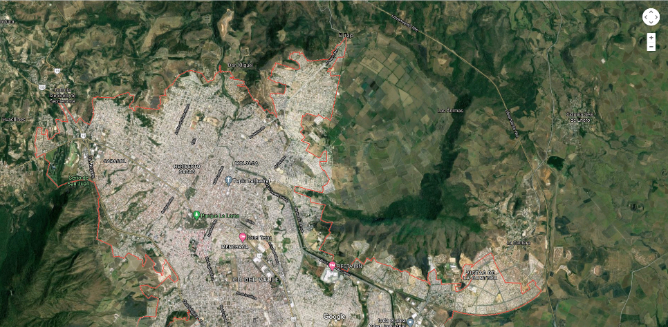

**Volcanic Crater**

**City of Tepic**

## Remember

**What do you remember about tectonic boundaries?**

1. What are the four types of tectonic boundaries?

|  |  |  |  |
| --- | --- | --- | --- |
| Boundary Type 1 | Boundary Type 2 | Boundary Type 3 | Boundary Type 4 |
|  |  |  |  |

1. Highlight or Circle the all boundaries you entered in the table above that we know produce volcanoes?

**What do you remember about types of volcanos?**

*Note: Place your answers to questions 3 through 7 in the table below the questions.*

1. What are the three types of Volcanoes? (Place one type in each column (A, B, and C) on Row 3)
2. Label each volcano type with high, medium or low silica content (Row 4)
3. Label each volcano type with high, medium or low viscosity (Row 5)
4. Label each of these volcano types as High, Medium, or Low tendency to be explosive. (Row 6)
5. Select the type of material that most typically comes out of each type of volcano:

Cinders/Ash/Rock, Runny Lava, or Both (Row 7)

|  |  |  |  |  |
| --- | --- | --- | --- | --- |
|  | Remember **Table**  **(Answers for #3 through #7)** | **Volcano Type A** | **Volcano Type B** | **Volcano Type C** |
| #3 | Volcano Type (each of 3 types) |  |  |  |
| #4 | Silica Content (High, Med, Low) |  |  |  |
| #5 | Viscosity (High, Med, Low) |  |  |  |
| #6 | Explosive? (High, Med, Low) |  |  |  |
| #7 | Type of Material from Volcano |  |  |  |

## Understand

**What do you understand about silica content, viscosity and explosiveness?**

Answer numbers 8 and 9 based on the information in the Table above and what you learned in class.

1. Magma with low silica content will have (high or low) tendency to be explosive.

(Circle the correct answer.)

1. Magma with high silica content will have (high or low) viscosity. (Circle the correct answer.)

## Apply

**Apply what you remember to predict what type of volcano is in the area of Tepic (Nayarit) Mexico**

1. Which of the four tectonic boundary types is nearest to Tepic? (Hint: Use a map of tectonic plate boundaries.)
2. Does the type of tectonic boundary in your answer to the question above produce volcanoes?
3. Which one of the three types of volcanoes is produced at the tectonic boundary in #11? ***Circle*** the column in the Remember **Table** that matches your choice.

Use the original social media posts, and additional internet research to answer 13 - 18 in the Apply **Table.**

|  |  |  |
| --- | --- | --- |
| Apply **Table** | | Match  (Y/N) |
| What is the **Volcano’s name** in the post? | 13. |  |
| ***Volcano Type (One of the 3 types):***  Which of the three types of volcanoes is the Volcano in the post? | 14. |  |
| ***Type of Material: (Cinders, Ash, Rock, Lava, etc.)***  When it erupted, how did your research describe the material that came from the volcano? | 15. |  |
| ***Explosive (Low, Med, or High):***  When it erupted, was it highly explosive, not explosive or somewhere in the middle? | 16. |  |
| ***Silica Content (Low, Med, or High):***  Based on the material that came out and how explosive (or not) that it was, did this volcano contain a high, medium or low silica magma? | 17. |  |
| ***Viscosity (Low, Med, or High):***  Based on your answers to 16 and 17, does the volcano have low, medium or high viscosity magma? | 18. |  |

## Analyze

**Analyze the description of the Tepic volcano described in the post**

1. When did the Volcano in the post last erupt and when is it expected to erupt again?
2. Compare the Apply **Table** to the column you circled in theRemember **Table**. In the last column (**Match (Y/N)**), indicate which rows matched and which didn’t. Did the post match what science tells you is the truth about the area around Tepic? Why or why not?

Name Period Date



## Evaluate

The Comment: In one well-written paragraph, write your comment to the post. Include your claim, evidence from your research about this particular volcano and the city, and scientific reasoning connecting your evidence to the fact that the residents of Tepic in Nayarit should or should not be worried about the volcano and the city’s development plans.

Organize your Thoughts: Using a graphic organizer (CER, DBQ or MEALS) or your own note-taking style, outline the claim (thesis statement), the evidence you want to cite and the reasoning you will use to connect them all together.

The Claim: Choose one of the following as your claim.

1. **The people should worry!** - Your comment supports the concerns of the people in the city of Tepic that the government is not doing enough to protect them and prevent development, or
2. **There is nothing to worry about!** – Your comment defends the city and their expansion into the crater.

The Evidence: What proof do you have that your claim is correct? Gather evidence using the information from the original post, the notes and resources presented to you in class, the data you collected in this document, and any additional research.

The Reasoning: How does your evidence support your claim? Use scientific facts to connect your evidence to your claim. You may want to consider the following in your answer: what you learned in class about tectonic boundaries, the volcanoes that form on those boundaries, viscosity, silica content, how explosive they might be and what might come out of the volcanoes.